DATABASE MANAGEMENT SYSTEM (CT-261)

FINAL PROJECT

ECOMMERCE MANAGEMENT SYSTEM

MADE BY:

1. | HAMZA KHAN | DT-22048

Introduction:
The E-commerce Management System is designed to streamline and manage various aspects of online retail operations, including product management, customer data management, order processing, and inventory control. This system aims to enhance the efficiency of business processes, improve customer satisfaction, and provide a comprehensive data management solution for e-commerce businesses. The system leverages SQL for robust data management, ensuring data integrity and accessibility.

PROBLEMS IN MAJORITY ECOMMERCE MANAGEMENT SYSTEMS:

Centralised Data Management:
  - The system efficiently centralizes customer, product, order, and payment information. This ensures that all relevant data is stored in an organized manner, making it easier to manage and retrieve data.

Relationships Between Entities:
  - The ERD clearly defines relationships between various entities such as customers, products, carts, orders, and payments. This ensures data integrity and consistency across the database, which might not be as robust in less well-designed systems.

Flexibility and Scalability
  - The system’s modular design allows for easy scalability. The product entity includes attributes such as type, colour, size, gender, and commission, which allows for a high degree of customization and flexibility in handling diverse product types.

Abstract:
This report presents the development and implementation of an E- commerce Management System using SQL. It includes the design of an Entity-Relationship Diagram (ERD), normalization of database tables up to the third normal form (3NF), and various SQL queries demonstrating Data Manipulation Language (DML), Data Definition Language (DDL), and join operations. The system is designed to optimize data management for online retail operations, ensuring efficient handling of product data, customer information, and order transactions.

Tables
- Cart: Stores cart IDs.
- Customer: Stores customer details, including a foreign key to the Cart.
- Seller: Stores seller details.
- Seller_Phone_num: Stores seller phone numbers.
- Payment: Stores payment details, including foreign keys to Customer and Cart.
- Product: Stores product details with a foreign key to Seller.
- Cart_item: Stores items in a cart with foreign keys to Cart and Product.
- Purchase_Order: Stores order details with a foreign key to Customer.
- Order_Item: Stores items in an order with foreign keys to
Purchase_Order and Product.
- Category: Stores product categories.

Procedures and Functions:
- order_summary: Displays an order summary.
- get_total_amount: Returns the total amount for an order.
- cost_filter: Filters products based on cost and type.
- totalProducts: Returns the total number of products for a seller.

- getProductQuantity: Returns the quantity of a specified product.
- numCartId: Returns the number of items in a cart.
- total_cost: Returns the total cost of items in a cart.

Primary Keys:
  - Cart: Cart_id
  - Customer: Customer_id
  - Seller: Seller_id
  - Seller_Phone_num: (Phone_num, Seller_id)
  - Payment: payment_id
  - Product: Product_id
  - Cart_item: (Cart_id, Product_id)
  - Purchase_Order: Order_id
  - Order_Item: Order_item_id
  - Category: Category_id

Foreign Keys:
  - Customer.Cart_id references Cart.Cart_id
  - Customer.Customer_id in Payment references
Customer.Customer_id
  - Product.Seller_id references Seller.Seller_id
  - Cart_item.Cart_id references Cart.Cart_id
  - Cart_item.Product_id references Product.Product_id
  - Purchase_Order.Customer_id references Customer.Customer_id
  - Order_Item.Order_id references Purchase_Order.Order_id
  - Order_Item.Product_id references Product.Product_id

Unique KEY:
Seller_Phone_num: (Phone_num, Seller_id)

CODE OF SQL:

CREATE DATABASE Ecommerce_Management; USE Ecommerce_Management;
-- Creating Tables CREATE TABLE Cart (
Cart_id VARCHAR(7) PRIMARY KEY
);
CREATE TABLE Customer (
Customer_id VARCHAR(6) PRIMARY KEY, c_pass VARCHAR(10) NOT NULL,
Name VARCHAR(20) NOT NULL, Address VARCHAR(20) NOT NULL, Pincode CHAR(6) NOT NULL,
Phone_number_s CHAR(10) NOT NULL, Cart_id VARCHAR(7) NOT NULL,
FOREIGN KEY (Cart_id) REFERENCES Cart(Cart_id)
);
CREATE TABLE Seller (
Seller_id VARCHAR(6) PRIMARY KEY, s_pass VARCHAR(10) NOT NULL, Name VARCHAR(20) NOT NULL, Address VARCHAR(10) NOT NULL
);
CREATE TABLE Seller_Phone_num ( Phone_num CHAR(10) NOT NULL, Seller_id VARCHAR(6) NOT NULL,
PRIMARY KEY (Phone_num, Seller_id),
FOREIGN KEY (Seller_id) REFERENCES Seller(Seller_id) ON DELETE CASCADE
);
CREATE TABLE Payment (
payment_id VARCHAR(7) PRIMARY KEY, payment_date DATE NOT NULL, Payment_type VARCHAR(10) NOT NULL, Customer_id VARCHAR(6) NOT NULL,

Cart_id VARCHAR(7) NOT NULL,
FOREIGN KEY (Customer_id) REFERENCES Customer(Customer_id),
FOREIGN KEY (Cart_id) REFERENCES Cart(Cart_id), total_amount DECIMAL(10, 2)
);
CREATE TABLE Product (
Product_id VARCHAR(7) PRIMARY KEY, Type VARCHAR(15) NOT NULL,
Color VARCHAR(15) NOT NULL, P_Size VARCHAR(2) NOT NULL, Gender CHAR(1) NOT NULL, Commission DECIMAL(5, 2) NOT NULL, Cost DECIMAL(10, 2) NOT NULL,
Quantity INT NOT NULL, Seller_id VARCHAR(6),
FOREIGN KEY (Seller_id) REFERENCES Seller(Seller_id) ON DELETE SET NULL
);
CREATE TABLE Cart_item ( Quantity_wished INT NOT NULL, Date_Added DATE NOT NULL, Cart_id VARCHAR(7) NOT NULL,
Product_id VARCHAR(7) NOT NULL, purchased VARCHAR(3) DEFAULT 'NO',
FOREIGN KEY (Cart_id) REFERENCES Cart(Cart_id), FOREIGN KEY (Product_id) REFERENCES Product(Product_id), PRIMARY KEY (Cart_id, Product_id)
);
CREATE TABLE Purchase_Order ( Order_id VARCHAR(7) PRIMARY KEY,
Order_date DATE NOT NULL, Customer_id VARCHAR(6) NOT NULL, Total_amount DECIMAL(10, 2),
FOREIGN KEY (Customer_id) REFERENCES Customer(Customer_id)
);
CREATE TABLE Order_Item (
Order_item_id VARCHAR(7) PRIMARY KEY,

Order_id VARCHAR(7) NOT NULL,
Product_id VARCHAR(7) NOT NULL, Quantity INT NOT NULL,
Unit_price DECIMAL(10, 2) NOT NULL, FOREIGN KEY (Order_id) REFERENCES
Purchase_Order(Order_id),
FOREIGN KEY (Product_id) REFERENCES Product(Product_id)
);
CREATE TABLE Category (
Category_id VARCHAR(7) PRIMARY KEY, Category_name VARCHAR(20) NOT NULL, Description VARCHAR(50)
);

-- Procedures and Functions DELIMITER //
CREATE PROCEDURE order_summary(IN param_order_id VARCHAR(7))

BEGIN
SELECT po.Order_id, po.Order_date, po.Total_amount,
c.Name AS Customer_Name, c.Address AS Customer_Address, c.Pincode, c.Phone_number_s
FROM Purchase_Order po
JOIN Customer c ON po.Customer_id = c.Customer_id WHERE po.Order_id = param_order_id;
SELECT oi.Order_item_id, p.Product_id, p.Type, p.Color, p.P_Size, p.Gender, oi.Quantity, oi.Unit_price
FROM Order_Item oi
JOIN Product p ON oi.Product_id = p.Product_id WHERE oi.Order_id = param_order_id;

END //
CREATE FUNCTION get_total_amount(param_order_id VARCHAR(7)) RETURNS DECIMAL(10, 2)

DETERMINISTIC BEGIN
DECLARE total_amount DECIMAL(10, 2);
SELECT SUM(oi.Quantity * oi.Unit_price) INTO total_amount FROM Order_Item oi

WHERE oi.Order_id = param_order_id; RETURN total_amount;

END //
-- New Procedures, Functions, and Triggers
CREATE PROCEDURE cost_filter(IN c DECIMAL(10, 2), IN t VARCHAR(7))

BEGIN
DECLARE cs DECIMAL(10, 2); DECLARE ty VARCHAR(7); DECLARE id VARCHAR(7);
DECLARE done INT DEFAULT 0; DECLARE cf CURSOR FOR
SELECT Product_id, Cost, Type FROM Product WHERE Cost < c AND Type = t;
DECLARE CONTINUE HANDLER FOR NOT FOUND SET done = 1;
OPEN cf;
read_loop: LOOP
FETCH cf INTO id, cs, ty; IF done THEN
LEAVE read_loop; END IF;
SELECT CONCAT('Product ', id, ' has cost ', cs, ' and the type is ',
ty);
END LOOP; CLOSE cf;

END //
CREATE FUNCTION totalProducts(sId VARCHAR(6)) RETURNS INT

DETERMINISTIC BEGIN
DECLARE total_count INT;
SELECT COUNT(*) INTO total_count FROM Product
WHERE Seller_id = sId; RETURN total_count;

END //
CREATE PROCEDURE getProductQuantity(p_id VARCHAR(7)) BEGIN

DECLARE quan INT;
DECLARE product_not_found BOOLEAN DEFAULT FALSE;
SELECT Quantity INTO quan FROM Product
WHERE Product_id = p_id;
IF quan IS NULL THEN
SET product_not_found = TRUE; END IF;
IF product_not_found THEN
SIGNAL SQLSTATE '45000' SET MESSAGE_TEXT = 'Sorry, no
such product exists!'; ELSE
SELECT quan AS Product_Quantity; END IF;

END //
CREATE FUNCTION numCartId(cd VARCHAR(7)) RETURNS INT

DETERMINISTIC BEGIN
DECLARE total INT DEFAULT 0; SELECT COUNT(*) INTO total
FROM Cart_item WHERE Cart_id = cd; RETURN total;

END //
CREATE TRIGGER before_customer BEFORE INSERT ON Customer FOR EACH ROW

BEGIN
DECLARE n INT;
SET n = numCartId(NEW.Cart_id); IF n > 0 THEN
SIGNAL SQLSTATE '45000' SET MESSAGE_TEXT = 'Cart ID
already exists!'; END IF;

END //
CREATE FUNCTION total_cost(cId VARCHAR(7))

RETURNS DECIMAL(10, 2) DETERMINISTIC
BEGIN
DECLARE total DECIMAL(10, 2) DEFAULT 0.00;
SELECT SUM(p.Cost) INTO total FROM Product p
INNER JOIN Cart_item ci ON p.Product_id = ci.Product_id WHERE ci.Cart_id = cId;
RETURN total;

END //
CREATE TRIGGER before_pay_up BEFORE INSERT ON Payment FOR EACH ROW

BEGIN
DECLARE total_cost DECIMAL(10, 2); SET total_cost = total_cost(NEW.Cart_id); SET NEW.total_amount = total_cost;

END // DELIMITER ;
-- Usage of procedure and function CALL order_summary('ord003');
SELECT get_total_amount('ord003') AS Total_Amount; CALL cost_filter(1000, 'jeans');
SELECT totalProducts('sid100') AS TotalProducts; CALL getProductQuantity('pid1001');

INSERTION:
INSERT INTO Cart (Cart_id) VALUES
('crt1012'), ('crt1013'), ('crt1014'), ('crt1015'), ('crt1011'), ('crt1016'), ('crt1021');
INSERT INTO Customer (Customer_id, c_pass, Name, Address, Pincode, Phone_number_s, Cart_id)

VALUES
('cid101', 'pass101', 'Alice', 'A-123', '100001', '1234567890', 'crt1012'),
('cid102', 'pass102', 'Bob', 'B-456', '200002', '2345678901', 'crt1013'),
('cid103', 'pass103', 'Charlie', 'C-789', '300003', '3456789012', 'crt1014'),
('cid100', 'ABCM1235', 'rajat', 'G-453', '632014', '9893135876', 'crt1016'),
('cid104', 'pass104', 'David', 'D-789', '400004', '4567890123', 'crt1015'),
('cid105', 'pass105', 'Emily', 'E-012', '500005', '5678901234', 'crt1016');
INSERT INTO Seller (Seller_id, s_pass, Name, Address) VALUES
('sid101', 'pass101', 'John', 'NY'),
('sid102', 'pass102', 'Jane', 'LA'),
('sid103', 'pass103', 'Smith', 'SF'),
('sid100', '12345', 'aman', 'delhi cmc');
INSERT INTO Seller_Phone_num (Phone_num, Seller_id) VALUES ('1122334455', 'sid101'), ('2233445566', 'sid102'), ('3344556677',
'sid103'), ('9943336206', 'sid100');
INSERT INTO Product (Product_id, Type, Color, P_Size, Gender, Commission, Cost, Quantity, Seller_id)

VALUES
('pid1006', 'Electronics', 'orange', 'M', 'M', 15, 500, 50, 'sid101'),
('pid1002', 'shirt', 'blue', 'M', 'M', 15, 500, 50, 'sid101'),
('pid1003', 'dress', 'green', 'L', 'F', 20, 1500, 30, 'sid102'),
('pid1004', 't-shirt', 'black', 'S', 'M', 10, 300, 100, 'sid103'),
('pid1005', 'jeans', 'blue', '30', 'F', 12, 800, 25, 'sid100'),
('pid1001', 'jeans', 'red', '32', 'M', 10, 1000.5, 20, 'sid100'),
('pid1007', 'jeans', 'blue', '32', 'F', 12, 800, 25, 'sid101'),
('pid1008', 'jeans', 'black', '32', 'F', 12, 750, 10, 'sid102'),
('pid1009', 'Clothing', 'White', 'S', 'F', 10, 700, 20, 'sid102'),
('pid1011', 'jeans', 'blue', '32', 'F', 12, 700, 20, 'sid101');

INSERT INTO Cart_item (Quantity_wished, Date_Added, Cart_id, Product_id, purchased)

VALUES
(2, STR_TO_DATE('10-JUN-2023', '%d-%b-%Y'), 'crt1012', 'pid1002', 'YES'),
(1, STR_TO_DATE('12-JUN-2023', '%d-%b-%Y'), 'crt1013', 'pid1003', 'NO'),
(3, STR_TO_DATE('15-JUN-2023', '%d-%b-%Y'), 'crt1014', 'pid1004', 'YES'),
(3, STR_TO_DATE('10-OCT-1999', '%d-%b-%Y'), 'crt1011', 'pid1001', 'YES'),
(2, STR_TO_DATE('2023-06-10', '%Y-%m-%d'), 'crt1016', 'pid1002', 'NO'),
(1, STR_TO_DATE('2023-06-12', '%Y-%m-%d'), 'crt1016', 'pid1003', 'NO'),
(2, STR_TO_DATE('20-JUN-2023', '%d-%b-%Y'), 'crt1015', 'pid1003', 'NO'),
(1, STR_TO_DATE('22-JUN-2023', '%d-%b-%Y'), 'crt1016', 'pid1004', 'NO'),
(2, STR_TO_DATE('01-JUN-2023', '%d-%b-%Y'), 'crt1021', 'pid1011', 'YES');
INSERT INTO Payment (payment_id, payment_date, Payment_type,
Customer_id, Cart_id, total_amount) VALUES
('pmt1002', STR_TO_DATE('11-JUN-2023', '%d-%b-%Y'), 'credit', 'cid101', 'crt1012', 500),
('pmt1003', STR_TO_DATE('13-JUN-2023', '%d-%b-%Y'), 'debit', 'cid102', 'crt1013', 1500),
('pmt1004', STR_TO_DATE('16-JUN-2023', '%d-%b-%Y'), 'credit', 'cid103', 'crt1014', 900),
('pmt1001', STR_TO_DATE('11-JUN-2023', '%d-%b-%Y'), 'cash', 'cid100', 'crt1016', 1000);
INSERT INTO Purchase_Order (Order_id, Order_date, Customer_id, Total_amount)

VALUES
('ord001', STR_TO_DATE('2023-06-11', '%Y-%m-%d'), 'cid101', 500),
('ord002', STR_TO_DATE('2023-06-13', '%Y-%m-%d'), 'cid102', 1500),
('ord003', STR_TO_DATE('2023-06-16', '%Y-%m-%d'), 'cid103', 900),
('ord004', STR_TO_DATE('2023-06-10', '%Y-%m-%d'), 'cid100', 1000.5);

INSERT INTO Order_Item (Order_item_id, Order_id, Product_id, Quantity, Unit_price)

VALUES
('oit001', 'ord001', 'pid1001', 2, 200),
('oit002', 'ord002', 'pid1002', 3, 300),
('oit003', 'ord003', 'pid1003', 1, 500),
('oit004', 'ord004', 'pid1004', 2, 400);

Entity-Relationship Diagram (ERD):
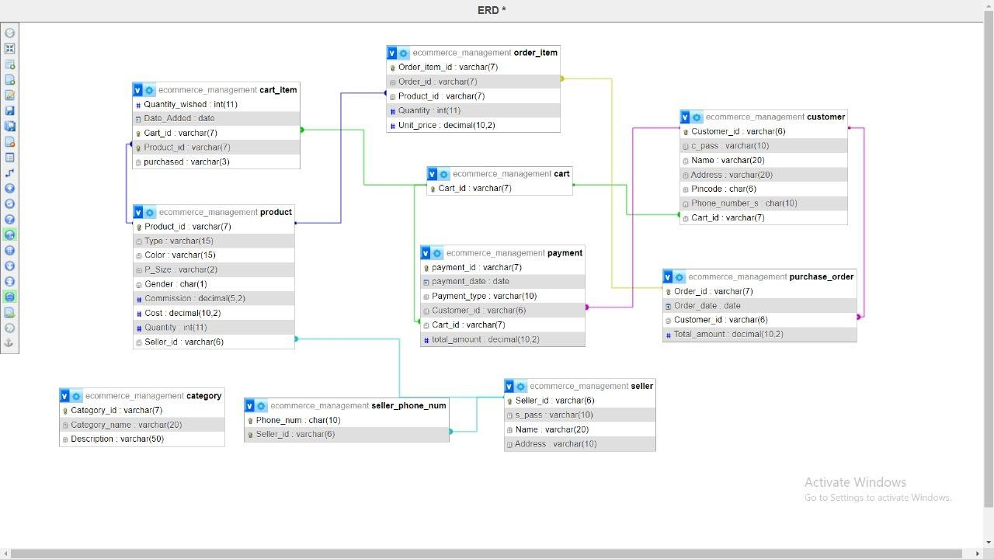
This ERD represents the e-commerce management system's structure by defining the entities, their attributes, and the relationships between them. The diagram shows how customers, sellers, products, orders, carts, payments, and other related entities are interconnected, helping to visualise and understand the database design for efficient data management and query handling.

Entities and Attributes:

Customer:
  - Attributes: Customer_id, c_pass, Name, Address, Pincode, Phone_number_s, Cart_id.

Seller:
  - Attributes: Seller_id, s_pass, Name, Address.

Product:
  - Attributes: Product_id, Type, Color, P_Size, Gender, Commission, Cost, Quantity, Seller_id.

Order Item:
  - Attributes: Order_item_id, Order_id, Product_id, Quantity, Unit_price.

Purchase Order:
  - Attributes: Order_id, Order_date, Customer_id, Total_amount.

Cart:
  - Attributes: Cart_id.

Cart Item:
  - Attributes: Quantity_wished, Date_Added, Cart_id, Product_id, purchased.

Payment:
  - Attributes: payment_id, payment_date, Payment_type, Customer_id, Cart_id, total_amount.

Seller Phone Number:
  - Attributes: Phone_num, Seller_id.

Category:
  - Attributes: Category_id, Category_name, Description.

Relationships:

One-to-Many (1:N):

  - Customer to purchase_order: A customer can have multiple orders.
  - Customer to payment: A customer can make multiple payments.
  - Seller to product: A seller can sell multiple products.
  - Seller to seller_phone_num: A seller can have multiple phone numbers.
  - purchase_order to order_item: An order can have multiple order items.
  - Cart to cart_item: A cart can contain multiple cart items.

Many-to-One (N:1):
  - purchase_order to Customer: Each order is made by one customer.
  - payment to Customer: Each payment is made by one customer.
  - payment to Cart: Each payment is associated with one cart.
  - order_item to purchase_order: Each order item is part of one order.
  - order_item to product: Each order item refers to one product.
  - cart_item to Cart: Each cart item belongs to one cart.
  - cart_item to product: Each cart item refers to one product.
  - product to Seller: Each product is sold by one seller.

One-to-One (1:1):
  - Customer to Cart: Each customer has one cart.

Join Queries:

SELECT oi.Product_id, oi.Quantity, po.Order_date, oi.Unit_price FROM Purchase_Order po
JOIN Order_Item oi ON po.Order_id = oi.Order_id WHERE po.Customer_id = 'cid101';

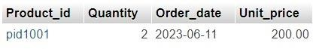

SELECT SUM(oi.Quantity * p.Cost * p.Commission / 100) AS total_profit FROM Order_Item oi
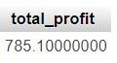
JOIN Product p ON oi.Product_id = p.Product_id;

SELECT po.Order_id, po.Order_date, oi.Product_id, oi.Quantity, oi.Unit_price, p.Type, p.Color
FROM Purchase_Order po
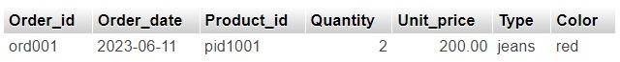
JOIN Order_Item oi ON po.Order_id = oi.Order_id JOIN Product p ON oi.Product_id = p.Product_id WHERE po.Customer_id = 'cid101';

Data Definition Language (DDL) Queries:

CREATE TABLE Customer (
Customer_id VARCHAR(6) PRIMARY KEY, c_pass VARCHAR(10) NOT NULL,
Name VARCHAR(20) NOT NULL, Address VARCHAR(20) NOT NULL, Pincode CHAR(6) NOT NULL,
Phone_number_s CHAR(10) NOT NULL, Cart_id VARCHAR(7) NOT NULL,
FOREIGN KEY (Cart_id) REFERENCES Cart(Cart_id)
);

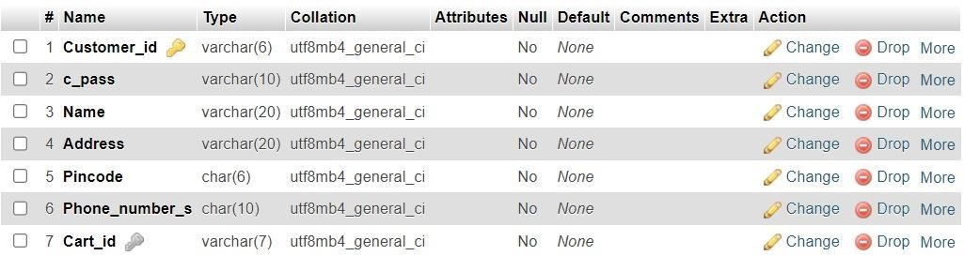

CREATE TABLE Seller (
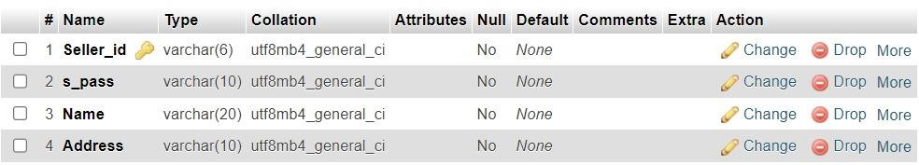
Seller_id VARCHAR(6) PRIMARY KEY, s_pass VARCHAR(10) NOT NULL, Name VARCHAR(20) NOT NULL, Address VARCHAR(10) NOT NULL

CREATE TABLE Payment (
payment_id VARCHAR(7) PRIMARY KEY, payment_date DATE NOT NULL, Payment_type VARCHAR(10) NOT NULL, Customer_id VARCHAR(6) NOT NULL, Cart_id VARCHAR(7) NOT NULL,
FOREIGN KEY (Customer_id) REFERENCES Customer(Customer_id), FOREIGN KEY (Cart_id) REFERENCES Cart(Cart_id),
total_amount DECIMAL(10, 2)
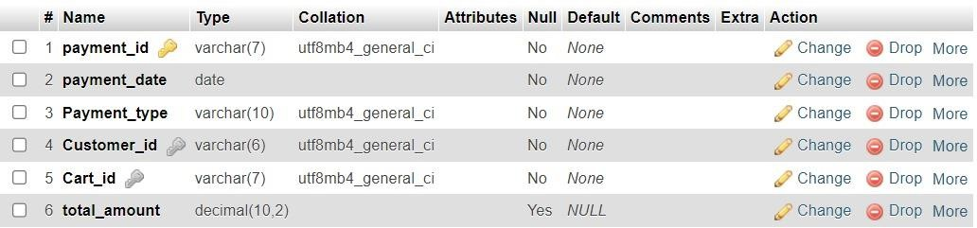
);

Data Manipulation Language (DML) Queries:

INSERT INTO Customer (Customer_id, c_pass, Name, Address, Pincode, Phone_number_s, Cart_id)

VALUES
('cid101', 'pass101', 'Alice', 'A-123', '100001', '1234567890', 'crt1012'),
('cid102', 'pass102', 'Bob', 'B-456', '200002', '2345678901', 'crt1013'),
('cid103', 'pass103', 'Charlie', 'C-789', '300003', '3456789012', 'crt1014'),
('cid100', 'ABCM1235', 'rajat', 'G-453', '632014', '9893135876', 'crt1016'),
('cid104', 'pass104', 'David', 'D-789', '400004', '4567890123', 'crt1015'),
('cid105', 'pass105', 'Emily', 'E-012', '500005', '5678901234', 'crt1016');

UPDATE Customer SET Cart_id = 'crt1021' WHERE Customer_id = 'cid101';
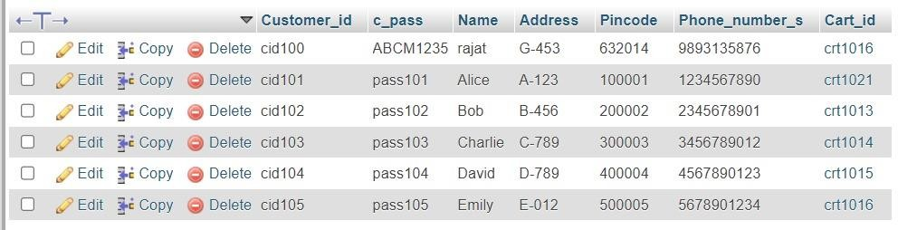

INSERT INTO Product (Product_id, Type, Color, P_Size, Gender, Commission, Cost, Quantity, Seller_id)

VALUES
('pid1006', 'Electronics', 'orange', 'M', 'M', 15, 500, 50, 'sid101'),
('pid1002', 'shirt', 'blue', 'M', 'M', 15, 500, 50, 'sid101'),
('pid1003', 'dress', 'green', 'L', 'F', 20, 1500, 30, 'sid102'),
('pid1004', 't-shirt', 'black', 'S', 'M', 10, 300, 100, 'sid103'),
('pid1005', 'jeans', 'blue', '30', 'F', 12, 800, 25, 'sid100'),
('pid1001', 'jeans', 'red', '32', 'M', 10, 1000.5, 20, 'sid100'),
('pid1007', 'jeans', 'blue', '32', 'F', 12, 800, 25, 'sid101'),
('pid1008', 'jeans', 'black', '32', 'F', 12, 750, 10, 'sid102'),
('pid1009', 'Clothing', 'White', 'S', 'F', 10, 700, 20, 'sid102'),
('pid1011', 'jeans', 'blue', '32', 'F', 12, 700, 20, 'sid101');

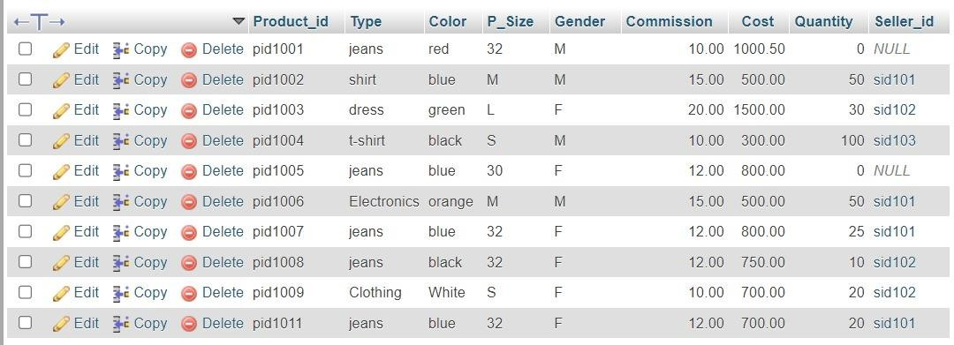

INSERT INTO Order_Item (Order_item_id, Order_id, Product_id, Quantity, Unit_price)

VALUES
('oit001', 'ord001', 'pid1001', 2, 200),
('oit002', 'ord002', 'pid1002', 3, 300),
('oit003', 'ord003', 'pid1003', 1, 500),
('oit004', 'ord004', 'pid1004', 2, 400);
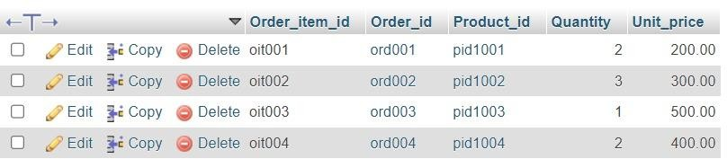

Normalization

Unnormalized Table

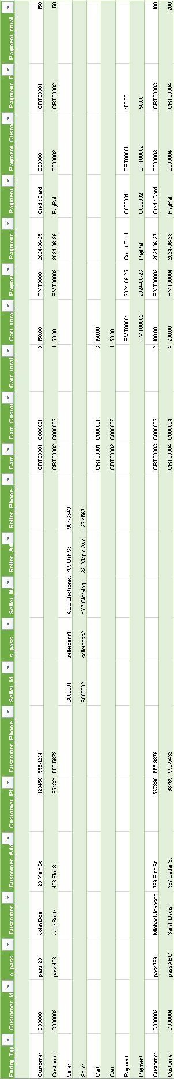

1st Normal Form:
Objective: Ensure that the table has only atomic (indivisible) values and each column contains only one value.

Actions Taken:
- Atomic Values: Ensure that each column contains atomic values (no repeating groups or arrays).
- Separate Entities: Separate different entities into their own tables.

Tables Created:
  - Customers Table: Contains individual customer data.
  - Sellers Table: Contains individual seller data.
  - Carts Table: Contains individual cart data.
  - Payments Table: Contains individual payment data.

Result:
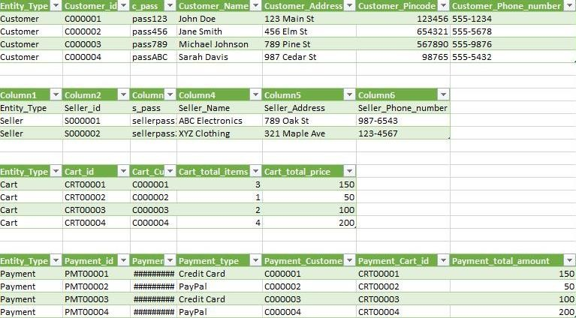

2nd Normal Form:
Objective: Ensure that the table is in 1NF and that all non-key attributes are fully dependent on the entire primary key (eliminating partial dependencies).

Actions Taken:
- Identify Primary Keys: Ensure each table has a clear primary key.

- Remove Partial Dependencies: Ensure all non-key attributes are fully dependent on the primary key.
2NF Review: In the given tables, no new tables are needed since all non-key attributes are already fully dependent on their respective primary keys.

3rd Normal Form:
Objective: Ensure that the table is in 2NF and that all non-key attributes are only dependent on the primary key (eliminating transitive dependencies).

Actions Taken:
- Identify Transitive Dependencies: Find attributes that depend on other non-key attributes.
- Create New Tables: Remove transitive dependencies by creating new tables and linking them through foreign keys.
Modifications:

  - Removed Payment_type from Payments Table and created a new Payment Types
table.

Result:
